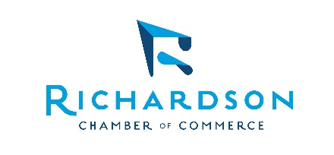
Media Contact:
Kim Quirk
kim@richardsonchamber.com
214-532-3771

FOR IMMEDIATE RELEASE

Richardson Chamber of Commerce Appoints

Anthony Moline as President and CEO
Richardson, TX, August 7, 2026 — The Richardson Chamber of Commerce Board of Directors is today announcing the appointment of Anthony (Tony) Moline as its new President and CEO, effective September 1, 2026.
Moline is coming to Richardson from Cedar Park, TX where he has led that chamber for 14 years. His achievements include tripling of revenue, growth in membership and achieving five-star accreditation from the US Chamber of Commerce, obtained by only 1% of chambers across the country and a designation shared by the Richardson Chamber.
"We are excited to welcome Tony to the Richardson Chamber," said Dr. Raul Hinojosa, Chair of the Board of Directors. "He will bring leadership and experience to the Chamber and execute on the great efforts we have in place."
Prior to Cedar Park, Moline held similar roles in Coppell and Lufkin. His expertise includes policy driven advocacy, sound financial stewardship, organizational influence and member connections. Additionally, he has served as the chair of the Texas Chamber of Commerce Executives, executive officer for the Texas Association of Business and on a board of the Association of Chamber of Commerce Executives.
"I am so thrilled to join the Richardson Chamber and get back home to North Texas,” said Moline. “I have such a respect for the organization and the city and what all has been accomplished in recent years. It will be an honor to be part of the continued success.”
Moline has roots in North Texas and graduated from Plano Senior High before receiving his Bachelor of Science degree in Political Science from Stephen F. Austin State University. His distinctions include Certified Chamber Executive (CCE), Institute for Organization Management (IOM) and Professional Community and Economic Developer (PCED).
Moline succeeds Kim Quirk, who was acting in an interim capacity and will continue as Executive Director of Leadership Richardson.

# # # #

About Richardson Chamber of Commerce
The Richardson Chamber of Commerce, celebrating its 80th anniversary, is a recognized five-star accredited chamber that drives prosperity for its members and community.

